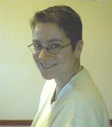  Anna Daiches  Clinical Director  a.daiches@lancaster.ac.uk  01524 594406 |   Jane Simpson  Research Director  j.simpson2@lancaster.ac.uk  01524 592858 | 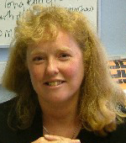  Cathy Amor  Senior Clinical Tutor,  Older Adult  c.amor@lancaster.ac.uk  01524 592975 | 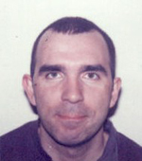  Tim Atkin  Senior Clinical Tutor,  Child and Family  t.atkin1@lancaster.ac.uk  01524 592979
  Jo Black  Clinical Tutor  j.black@lancaster.ac.uk  01524 594613 | 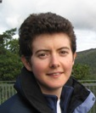  Fiona Eccles  Lecturer in Research Methods  f.eccles@lancaster.ac.uk  01524 592807 | 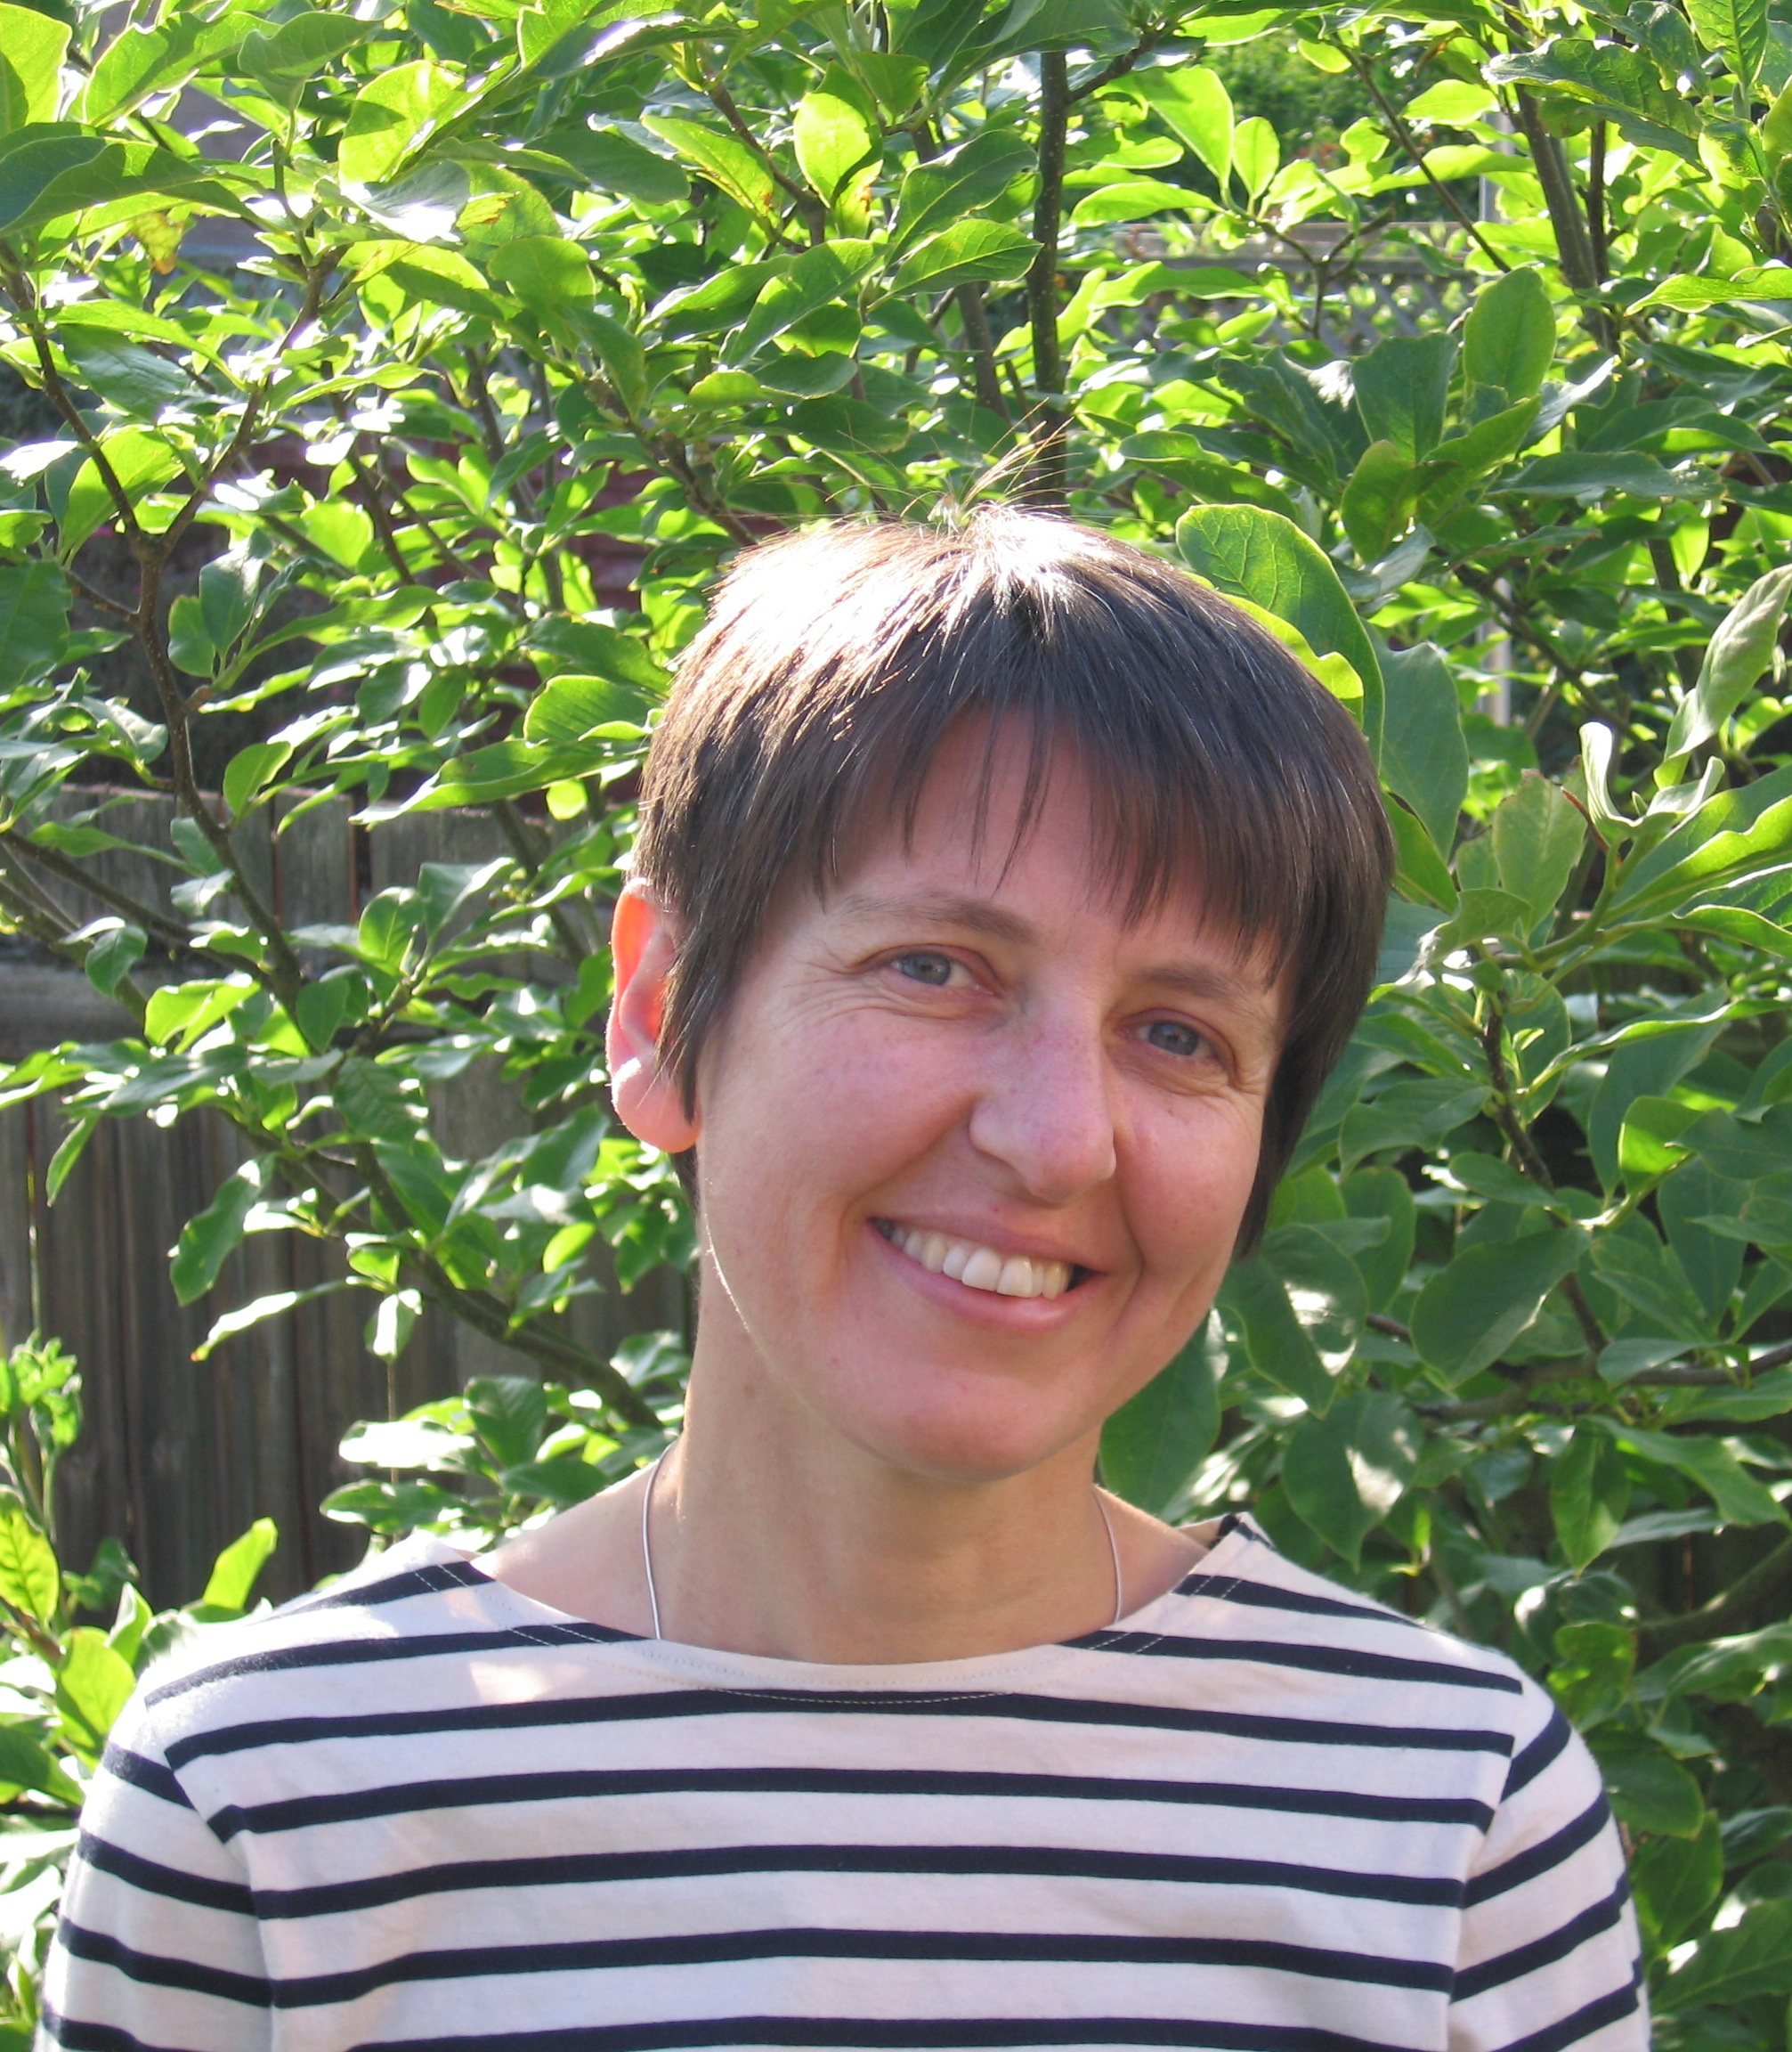  Suzanne Hodge  Research Lecturer  s.hodge@lancaster.ac.uk  01524 592712 |   Emma Munks  Clinical Tutor,  Learning Disabilities  e.munks@lancaster.ac.uk  01524 592945

  Jenny Davies  Clinical Tutor  j.davies1@lancaster.ac.uk  01524 592771 |   Ben Harper  Clinical Tutor  b.harper@lancaster.ac.uk  01524 594102 | 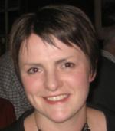  Clare Dixon  Clinical Tutor  c.dixon3@lancaster.ac.uk  01524 593492
  Craig Murray, Senior Lecturer in Qualitative Research Methods  c.murray@lancaster.ac.uk  01524 592730 | 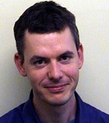  Richard Slinger  Clinical Tutor, Child & Family  r.slinger@lancaster.ac.uk  01524 593425 | 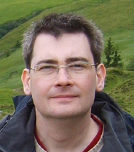  Ian Smith, Lecturer in Research Methods / Clinical Tutor, Adult  i.smith@lancaster.ac.uk  01524 592282 |   Ste Weatherhead  Clinical Tutor/Lecturer in Research Methods  s.weatherhead@lancaster.ac.uk

  Christina Pedder  Programme Assistant – Teaching  c.pedder@lancaster.ac.uk  01524 593378 | 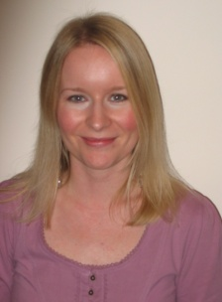  Katherine Thackeray  Programme Administrator  k.thackeray@lancaster.ac.uk  01524 92970 | 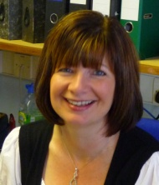  Jennifer Whitfield  Programme Secretary  j.whitfield@lancaster.ac.uk  01524 592972
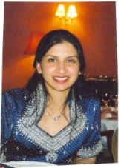  Ruby Allamby  Programme Assistant- Placements  r.allamby@lancaster.ac.uk  01524 592971 | 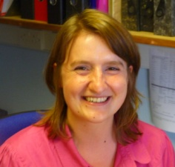  Sarah Heard  Research Coordinator  s.heard@lancaster.ac.uk  01524 592754

